Step - 1 Create Splash Screen Bundle

Before Uploading your Image should be 4096x4096 Pixels ,
if Not then Resize your Image

a - Re Size image Pixels
Open Web Browser and Open this Link Below or any online Image pixel resizer

Link : https://image.pi7.org/resize-image-pixel
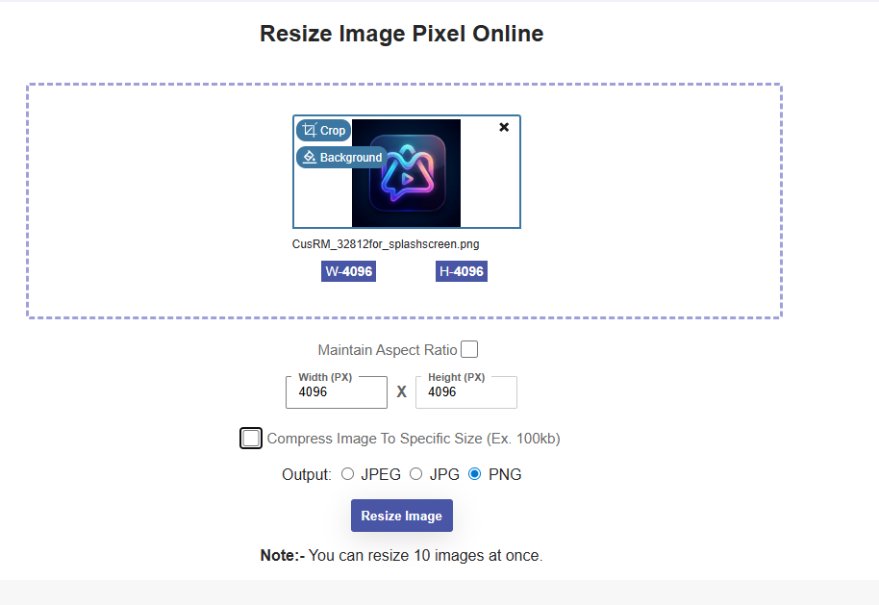

Download Resized Image

Step -2 Create splash screen bundle

Open Web Browser and Open this Link Below
Link : https://apetools.webprofusion.com/#/tools/imagegorilla
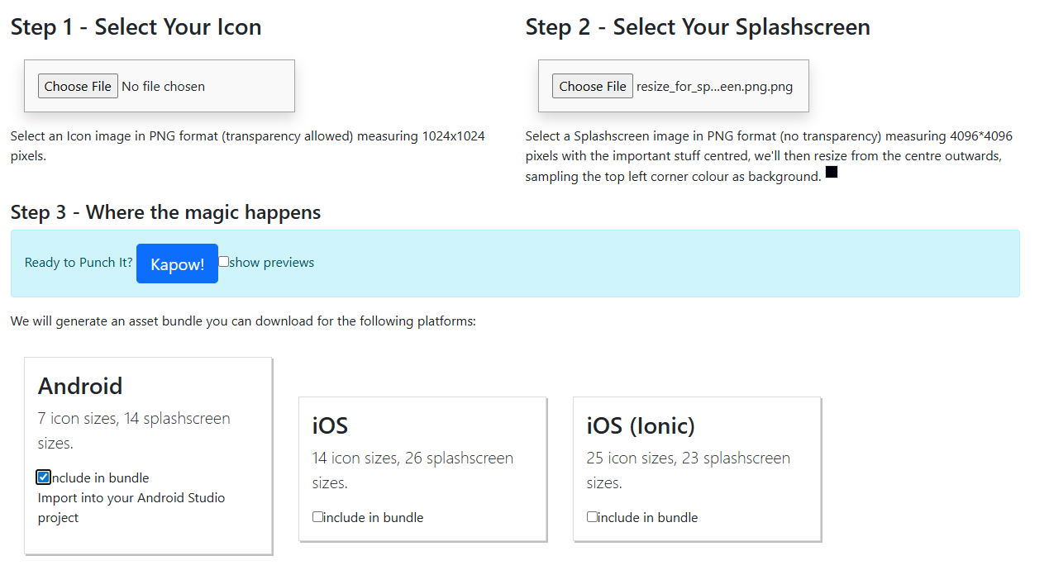

Choose
"Step 2 - Select Your Splashscreen"
and upload your Application Icon or image should be 4096x4096 Pixels.

- Check android check box
- CLick on "Kapaw" button under the Option "Step 3 - Where the magic happens"

- Download the Zip file and Extract it.

Step 3 Add Splash Screen Bundle

Copy all the folders inside extracted
ApeToolsGeneratedAssets\bundle\android
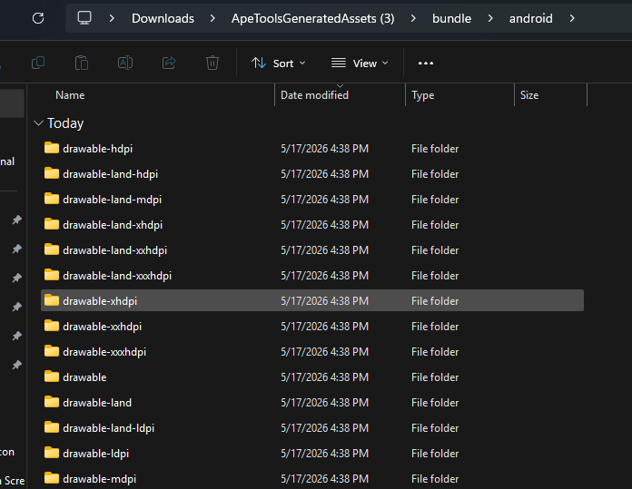

And past into the project Directory
android\app\src\main\res

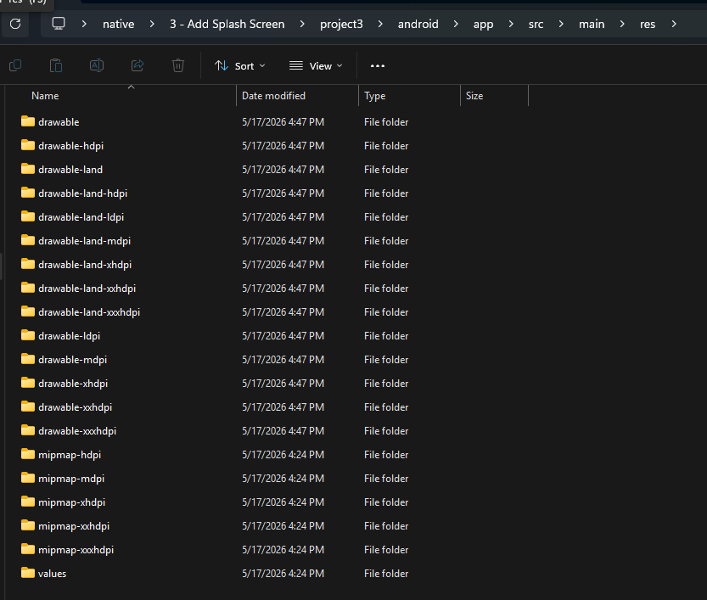

Step - 4 Installation and configuration

Install Library
>>> npm i react-native-splash-screen

- For Android, navigate to
android/app/src/main/java/com/splashscreen/MainActivity.kt file,
and add the following below the import.com.facebook.react.defaults.DefaultReactActivityDelegate line:

import android.os.Bundle
import org.devio.rn.splashscreen.SplashScreen

/**
* FOr Splash SplashScreen
**/
override fun onCreate(savedInstanceState: Bundle?) {
SplashScreen.show(this)
super.onCreate(savedInstanceState)
}

Complete code

package com.project

import com.facebook.react.ReactActivity
import com.facebook.react.ReactActivityDelegate
import com.facebook.react.defaults.DefaultNewArchitectureEntryPoint.fabricEnabled
import com.facebook.react.defaults.DefaultReactActivityDelegate
import android.os.Bundle
import org.devio.rn.splashscreen.SplashScreen

class MainActivity : ReactActivity() {

override fun getMainComponentName(): String = "project"

override fun onCreate(savedInstanceState: Bundle?) {
SplashScreen.show(this)
super.onCreate(savedInstanceState)
}

override fun createReactActivityDelegate(): ReactActivityDelegate =
DefaultReactActivityDelegate(this, mainComponentName, fabricEnabled)
}

Step -5 Create launch_screen.xml
Next, create a "layout" directory inside the android\app\src\main\res folder
then create a file "launch_screen.xml" inside the layout directory and add the following:

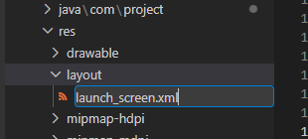

- Check your screen name inside android\app\src\main\res\drawable-land
image file name and rename the image name inside launch_screen.xml
from
android:src="@drawable/launch_screen"
to
android:src="@drawable/screen"

android\app\src\main\res\layout\launch_screen.xml

<?xml version="1.0" encoding="utf-8"?>
<RelativeLayout xmlns:android="http://schemas.android.com/apk/res/android"
android:layout_width="match_parent"
android:layout_height="match_parent"
android:background="#00000C">

<ImageView
android:id="@+id/splash_logo"
android:layout_width="260dp"
android:layout_height="260dp"
android:src="@drawable/screen"
android:scaleType="fitCenter"
android:layout_centerHorizontal="true"
android:layout_marginTop="120dp" />

<TextView
android:layout_width="wrap_content"
android:layout_height="wrap_content"
android:text="Your App Name"
android:textColor="#FFFFFF"
android:textSize="28sp"
android:textStyle="bold"
android:letterSpacing="0.1"
android:layout_centerHorizontal="true"
android:layout_below="@id/splash_logo"
android:layout_marginTop="24dp" />

</RelativeLayout>

Step – 6 Edit values.xml

android\app\src\main\res\values

- Than we will go to **values** folder inside **styles.xml** file and change with newly created file name:

android\app\src\main\res\values\styles.xml

<resources>

<!-- Base application theme. -->
<style name="AppTheme" parent="Theme.AppCompat.DayNight.NoActionBar">
<!-- Customize your theme here. -->
<item name="android:editTextBackground">@drawable/rn_edit_text_material</item>
</style>

</resources>

To

<resources>

<!-- Base application theme. -->
<style name="AppTheme" parent="Theme.AppCompat.DayNight.NoActionBar">
<!-- Customize your theme here. -->
<!-- <item name="android:editTextBackground">@drawable/rn_edit_text_material</item> -->
<item name="android:editTextBackground">@layout/launch_screen</item>
</style>

</resources>

Step – 7

Open android/gradle.properties
Add the following lines (if not present):

android.useAndroidX=true
android.enableJetifier=true

Step 8 – Add App.tsx

Create “assets“ folder application root directory inside app_logo and place the logo
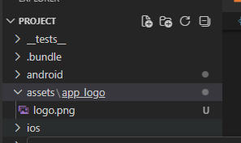

App.tsx
import React, { useEffect, useState } from 'react';
import {
View,
Text,
Image,
StyleSheet,
Platform,
Animated,
} from 'react-native';
import SplashScreen from 'react-native-splash-screen';

// ─── Animated Dots Component ───────────────────────────────────────────────
const LoadingDots = () => {
const [dots, setDots] = useState('');

useEffect(() => {
const interval = setInterval(() => {
setDots(prev => {
if (prev === '...') return '';
return prev + '.';
});
}, 400);

return () => clearInterval(interval);
}, []);

return (
<Text style={styles.dots}>
{dots}
</Text>
);
};

// ─── JS Splash Screen ──────────────────────────────────────────────────────
const JSSplashScreen = () => (
<View style={styles.splashContainer}>
<Image
// source={require('./assets/logo.png')}
source={require('./assets/app_logo/logo.png')}
style={styles.logo}
resizeMode="contain"
/>
<Text style={styles.appName}>Your App Name</Text>
<Text style={styles.tagline}>Your tagline here</Text>
<LoadingDots />
</View>
);

// ─── Main App ──────────────────────────────────────────────────────────────
const App = () => {
const [isReady, setIsReady] = useState(false);

useEffect(() => {
// 1. Hide native splash immediately — no timer
if (Platform.OS === 'android') {
SplashScreen.hide();
}

// 2. Run your actual startup tasks here
const initialize = async () => {
try {
// Add your real init tasks here, for example:
// await loadFonts();
// await fetchUserSession();
// await checkPermissions();

// Nothing to load? Just mark ready immediately:
setIsReady(true);

} catch (error) {
console.error('Initialization error:', error);
setIsReady(true); // still proceed even on error
}
};

initialize();
}, []);

// Show JS splash with animated dots until app is ready
if (!isReady) {
return <JSSplashScreen />;
}

// App is ready — show your real screen
return (
<View style={styles.appContainer}>
<Text style={styles.appText}>Welcome!</Text>
</View>
);
};

// ─── Styles ────────────────────────────────────────────────────────────────
const styles = StyleSheet.create({
splashContainer: {
flex: 1,
backgroundColor: '#00000C',
alignItems: 'center',
justifyContent: 'flex-start',
paddingTop: 120,
},
logo: {
width: 260,
height: 260,
},
appName: {
color: '#FFFFFF',
fontSize: 28,
fontWeight: 'bold',
letterSpacing: 1.5,
marginTop: 24,
},
tagline: {
color: '#8899BB',
fontSize: 15,
marginTop: 8,
},
dots: {
color: '#6677AA',
fontSize: 36,
letterSpacing: 6,
position: 'absolute',
bottom: 72,
width: 60, // fixed width so dots don't shift layout left/right
textAlign: 'center',
},
appContainer: {
flex: 1,
backgroundColor: '#00000C',
alignItems: 'center',
justifyContent: 'center',
},
appText: {
color: '#FFFFFF',
fontSize: 24,
},
});

export default App;

Restart the app

>>> cd android
>>> gradlew clean
>>> cd ..
>>> npx react-native run-android

>>> npx react-native run-android

